OWS Personalization

1. Customers

Add Action Seq 12.5 to Personalization with Seq 70.

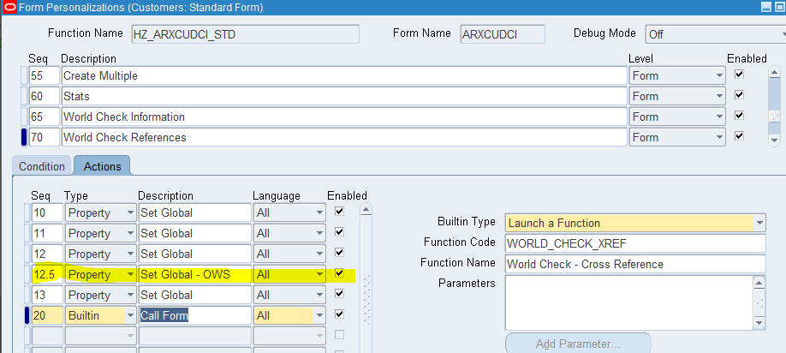

1. NRMI

Add sequence 12.5

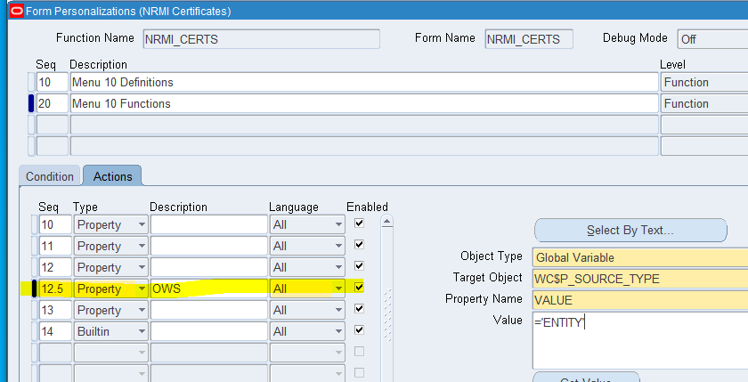

1. Corporations

Add Seq 12.5 to Personalization Seq 30

Add Seq 12.5 to Personalization Seq 40

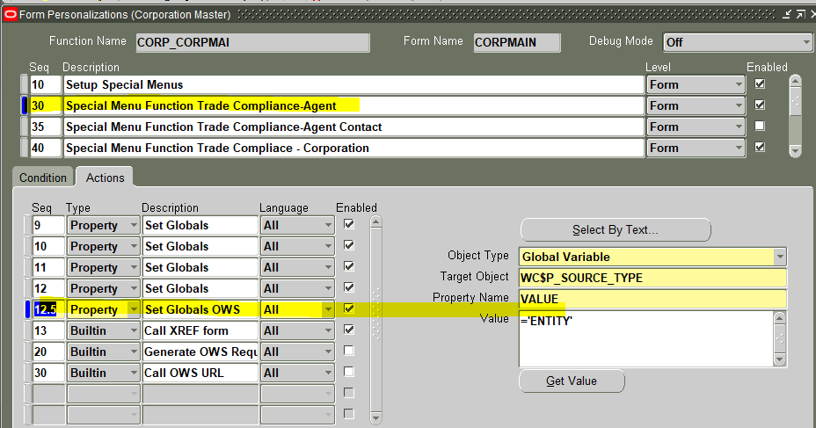

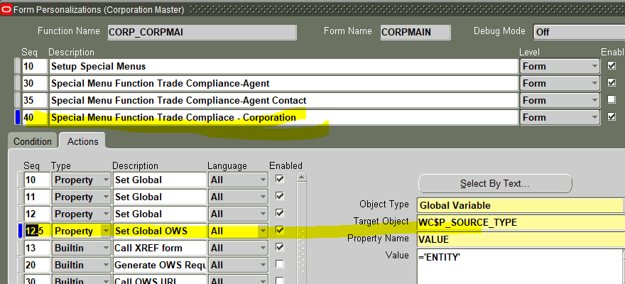

1. Inspectors Company

Disable Action Seq 10 for Personalization Seq 30

Add Action Seq 11 for Personalization Seq 30

Add Action Seq 12.5 for Personalization Seq 20

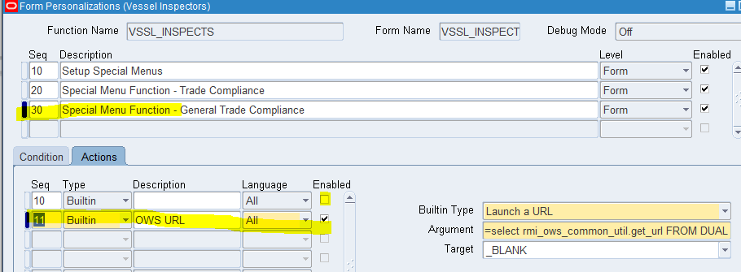

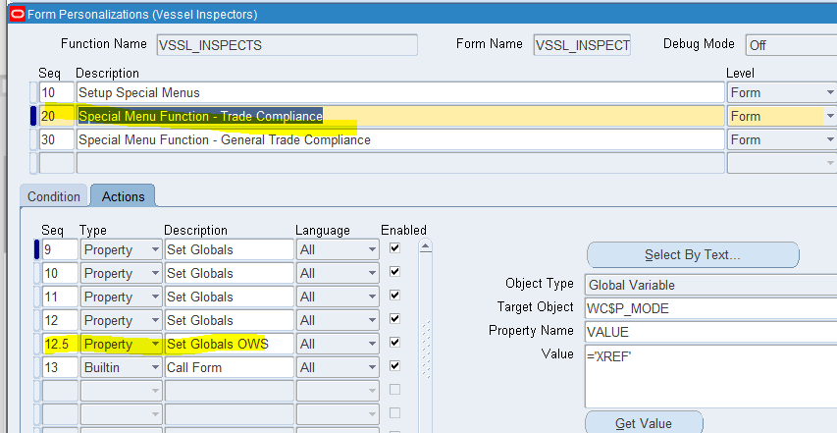

1. Vessel

Add action seq 12.5 to Personalization seq 20

Add action seq 12.5 to Personalization seq 30

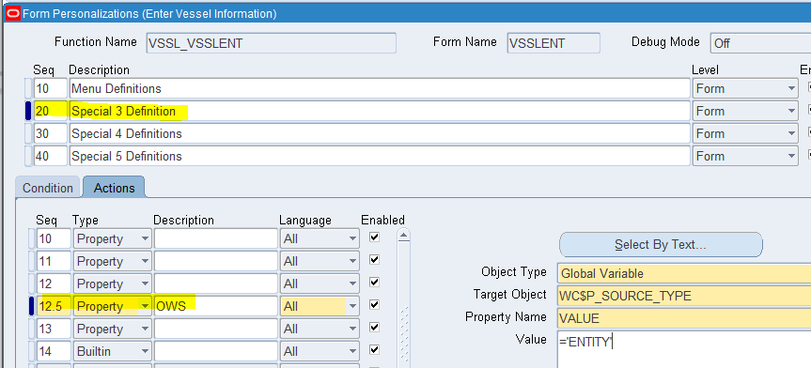

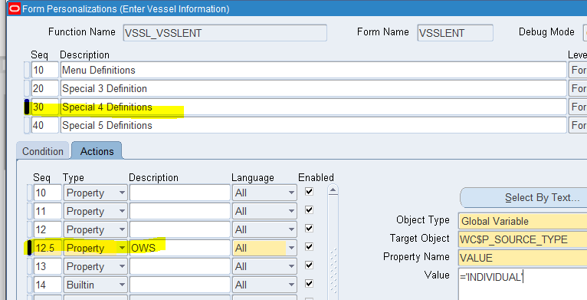

1. Vessel Vetting

Add action seq 12.5 to Personalization 20

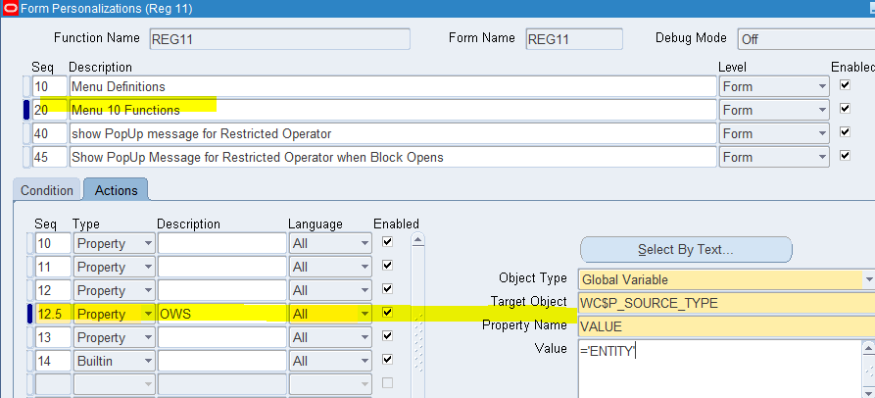

1. Seafarers

Add seq 12.5 to Personalization 20

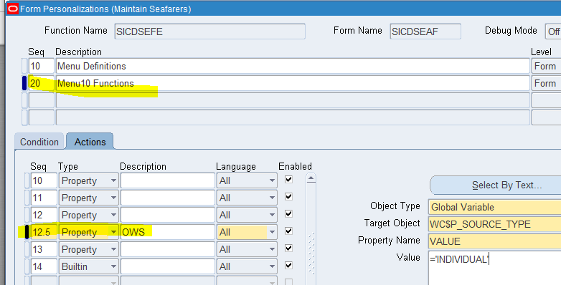

Edit Seafarer -

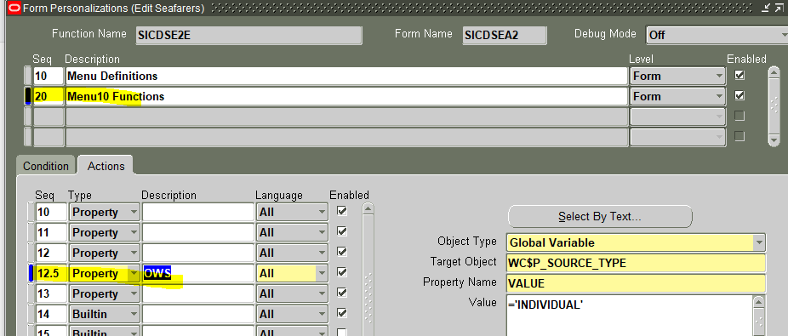s

1. External Seafarers

Add seq 30.5 to Personalization 20

